Manage personal information

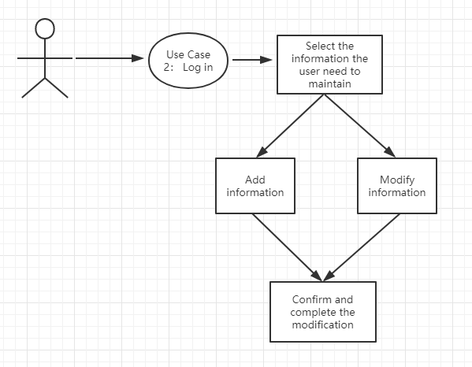

|  |  |
| --- | --- |
| Use case: 3 | Manage personal information |
| Related Requirem’ts | Req-2、Req-3 |
| Initiating Actor | user |
| Actor’s Goal | Improve or modify user’s personal information, including name, contact information, shipping address, etc. |
| Participating Actors | User, Data base |
| Preconditions | The user has successfully logged in and is ready to maintain personal information |
| Postconditions | Successfully connected to the system database for read/write operations |
| Flow of Events for Main Success Scenario | 1. Select the information box to be maintained.  2. Add/modify information that needs to be maintained  3. Click OK to save your changes. |

Use case: payment procedure

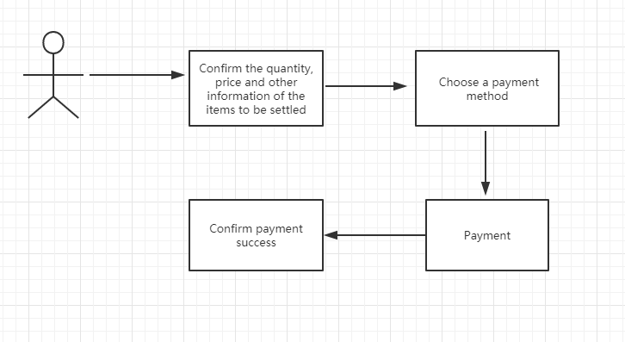

|  |  |
| --- | --- |
| Use case: 10 | payment procedure |
| Related Requirem’ts | Req-8 |
| Initiating Actor | user |
| Actor’s Goal | Confirm the price of the item purchased by the user and pay |
| Participating Actors | User, Data base |
| Preconditions | The user has added the item he wants to purchase to the shopping cart and is ready to check out |
| Postconditions | The system detects the price, quantity and other information of the product selected by the user and calculates the price. The database checks the inventory information and prepares for modification. |
| Flow of Events for Main Success Scenario | 1. Confirm the quantity, price and other information of the items to be settled  2. Choose a payment method  3. Payment  4. Confirm payment success |